SH120-II Digital microhematocrit centrifuge

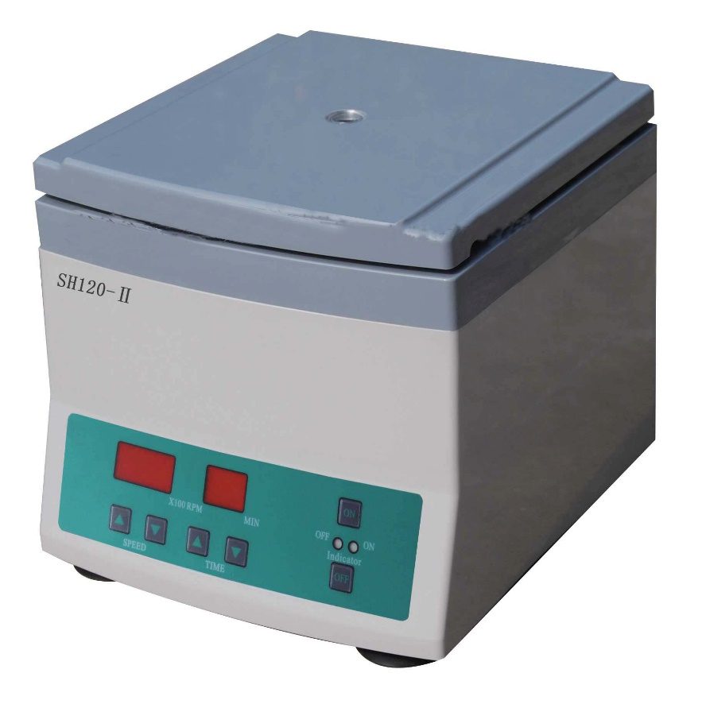
Spec:
Brushless motor available, easy & safe-to-use, low noise, touch key interface.
Max speed | 12000rpm Stepless regulation
Max rcf | 15300xg
Capactiy | dia 1.5mm*75mm(24capillary tubes)
Timer | 0-99min
Digital display | Yes, speed indication, digital control panel
Power Supply | AC 220V/110V 50Hz/60Hz
Safety control | Mechanical lid lock. Auto pause device (Automatic stop when lid is open during operation)

Packaging Details
Pack: carton (1 set in 1 box)
G.W/N.W: 11kg/10kg
Size: 28L*31W*27H (cm) 