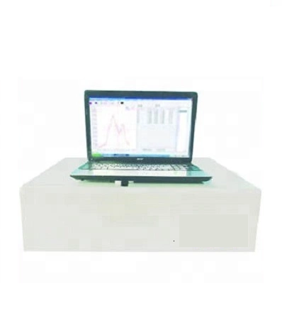

**Infrared Spectrometric Oil Detector, Infrared Oil Content Analyzer, BK-IOCA**

**Introduction:**

**It can be applied to monitor the oil content in surface water, ground water and industrial effluent, and the oil of catering industry,oil content of solid.It is the professional instrument to monitor the oil content of water, gas, solid.**

**Features:**

1. Integration optics system, spectral before absorption,high signal-to-noise ratio.

2. Software can be adjusted and corrected automatically.  
3. Direct reading function of non-dispersive measurement results, with mathematical statistics, spectral display and storage printing function.

4. It can be used to measure the purity of organic materials, such as CCl4.

5. RS232 or USB2.0 interface.

6. Use S-316, C2Cl4,CCl2FCClF2,and other non-carbon chlorinated organic solvent as extractant.

**Technical Parameters:**

|  |  |
| --- | --- |
| Model | BK-IOCA |
| Measurement Range | 0.2~100mg/L |
| Detection Limit | <0.15mg/L(CCl4 extract,5cm quartz cuvette)  <0.002mg/L(Water samples,using extraction ratio 100:1, 5cm quartz cuvette) |
| Max. Measured Concentration | 64000 mg/L |
| Measurement Accuracy | ±2%(C=40mg/L) |
| Repeatability Accuracy | <2% (for 20~40mg/L oil sample) |
| Linearly Dependent Coefficient | R>0.999 |
| Wavelength Range | 3400cm-1~2400cm-1(2940nm~4167nm) |
| Wavelength Accuracy | ±2 cm -1 |
| Wavelength Repeatability | ±2 cm -1 |
| Absorbance Range | 0.00000~3.00000AU |
| Sample Analysis Time | Full spectra scan, 30s/time;  Fixed several times scan, 10s/time;  Non-dispersed infrared method, 2s/time. |
| Blank Solvent Zero Setting | Automatic |
| Environment Requirement | 5℃~35℃, 20%~85%RH, no acute shaking, no strong electromagnetic field interference, no corrosive gas. |
| Power Supply | AC110/220V±10%, 50/60Hz |
| External Size(L*W*H)mm | 550*380*150 |
| Package Size(L*W*H)mm | 650*480*250 |
| Gross Weight(kg) | 17.5 |